# Final Year Project Report

**Full Unit: Final Report**

Project Title: Personalized Learning Pathway Recommendation System for Post-secondary Somali Learners Using Collaborative Filtering

Abdirahman Ibrahim Tigow Abdirahman Osman Mohamed

A report submitted in part fulfilment of the degree of

 **Information Technology Supervisor:** Ubaid Mohamed Dahir

Department of Information Technology Faculty of computing, Simad University

0

Jan 2025

## DECLARATION

“I declare that the following is my own work and does not contain any unacknowledged work from any other sources. This project was undertaken to fulfill the requirements of the bachelor’s degree program in Computer Science/Information Technology/Graphics, and Multimedia at Simad University”.

Signature: …………………………… Name : ……………………………

Signature: ……………………………

Name : ……………………………

Date : ……………………….……

## ACKNOWLEDGEMENTS

I am deeply grateful to my supervisor, Ubaid Mohamed Dahir, for his invaluable guidance, patience, and encouragement throughout this research. His insightful advice and continuous support have been instrumental in shaping this work.

I extend my appreciation to my Simad University and faculty members for providing a strong academic foundation and the necessary resources to complete this thesis. Their dedication to acknowledge and education has greatly inspired me.

A heartfelt thank you to my family whose unwavering support and motivation gave me the strength to overcome challenges along the way. Their belief in me has been my greatest source of inspiration.

Lastly, I acknowledge everyone who contributed in any way to this research. Your help, has made a difference, and I truly appreciate it.

## ABSTRACT

Personalized learning systems are becoming increasingly important in educational settings, offering tailored learning experiences based on individual students' needs and progress. However, most existing systems are designed for English-speaking learners and fail to accommodate linguistic and contextual differences, particularly in non-English-speaking communities. This study proposes the development of a ***Personalized Learning Pathway Recommendation System for Somali Learners*** using Collaborative Filtering (CF). By analysing student learning behaviour, the system aims to provide adaptive recommendations that enhance student engagement, retention, and overall performance.

The system utilizes ***Collaborative Filtering***, a machine learning technique that identifies patterns in user behavior to recommend the most suitable learning resources. By analyzing student data, such as quiz scores, study time, and engagement levels, the system suggests personalized learning paths that adjust in real-time to the evolving needs of individual learners. This study specifically focuses on Somali learners, incorporating culturally relevant content and educational resources in Somali to enhance accessibility and engagement.

This research evaluates the effectiveness of the proposed recommendation system in a Somali educational environment, with a focus on improving learning outcomes and providing educators with valuable insights into student progress. This research contributes to the growing field of AI in education, offering insights into adaptive learning technologies and their impact on digital learning platforms.

**TABLE OF CONTENTS**

DECLARATION ii

ACKNOWLEDGEMENTS ii

ABSTRACT ii

TABLE OF CONTENTS ii

LIST OF TABLES ii

LIST OF FIGURES ii

LIST OF ABBREVIATIONS AND SYMBOLS ii

1. INTRODUCTION… 1

1.1 BACKGROUND……………………………………………………………………………

1.2 PROBLEM STATEMENT…………………………………………………………………

1.3 OBJECTIVES………………………………………………………………………………

1.4 SIGNIFICANCE OF THE STUDY………………………………………………………

1.5 RESEARCH QUESTIONS…………………………………………………………………

1.6 CHAPTER SUMMARY……………………………………………………………………

1.7 BOOK ARRANGEMENT………………………………………………………………….

2. LITERATURE REVIEW 2

2.1 INTRODCUTION………………………………………………………………………….

2.2 RELATED WORKS………………………………………………………………………….

2.3 COLLABORATIVE FILTERING IN EDUCATIONAL RECOMMENDATION SYSTEMS………………….

2.4 MACHINE LEARNING TECHNIQUES FOR PERSONALIZED LEARNING………

2.5 LITERATURE GAP ANALYSIS………………………………………………………….

2.6 CHAPTER SUMMARY…………………………………………………………………….

3. RESEARCH METHODOLOGY

3.1 INTRODUCTION…………………………………………………………………………...

3.2 CONCEPTUAL FRAMEWORK ……………………………………………………………

3.3 DATA COLLECTION METHODS ……………………………………………………….

3.4 SYSTEM DESIGN AND ARCHITECTURE………………………………………………

3.5 CHAPTER SUMMARY ………………………………………………………………….

4. RESULTS AND DISCUSSION 4

5. CONCLUSION & LESSON LEARNED 5

6. REFERENCES 6

APPENDICES 7

## LIST OF TABLES

Table 1.1: Summary of System Analysis and Design Methodologies 2

Table 1.1: Acceptable conditions for sewage discharge standards

## LIST OF FIGURES

Figure 1.1: An example system and its environment 2

Figure 2.1. Classification of wastewater treatment methods

## LIST OF ABBREVIATIONS AND SYMBOLS

HTML - Hypertext Markup Language HTTP - HyperText Transport Protocol

# CHAPTER 1

# INTRODUCTION

Collaborative Filtering (CF) based techniques have become very popular for designing a recommendation system. Among them, the Matrix Factorization (MF) model that jointly learns the user and item latent factors for CF is tremendously successful, and has become one of the standard solutions. This study extends the existing matrix factorization model to handle a different type of task: recommending courses to the students.

Personalized Learning Path Planning **(**PLPP**)** has become a critical area in educational technology, aiming to tailor learning experiences to the unique needs, preferences, and prior knowledge of each learner. The significance of PLPP lies in its potential to enhance learning efficiency and effectiveness by providing customized educational pathways that adapt to the individual learning pace and style of each student. This approach not only fosters deeper understanding and retention but also increases learner engagement and motivation, which are crucial for successful educational outcomes(Ng & Fung, 2024).

As a result, students could find it difficult to connect with the content or might not get the help they require to be successful. On the other hand, personalized learning makes use of machine learning (ML) and artificial intelligence (AI) to develop dynamic, customized learning events that adapt to each student's particular learning style and speed(Xu et al., 2021).

In particular, Personalized learning pathway recommendation systems are made to analyse student behaviour and offer personalized study material recommendations. These systems have become more popular recently, particularly in e-learning settings where students engage with content remotely. Although personalized learning technologies have advanced, the majority of existing systems cater to English-speaking learners and do not address the difficulties faced by non-English-speaking communities, like Somali learners.

### Background

In recent years, personalized learning systems—which modify instructional materials to fit each student's particular need—have attracted a lot of interest. These systems examine student learning patterns using artificial intelligence (AI) and machine learning (ML) methods and offer recommendations for materials most fit for their degree of development. Conventional educational approaches may neglect to accommodate the several learning styles and pace of pupils, which results in disengagement and less successful learning results. On the other hand, personalized learning systems can guarantee that students have materials that fit their preferred learning style, therefore improving engagement, retention, and academic performance.

**Globally,** personalized learning has been used worldwide using several AI-driven recommendation systems, most famously on e-learning platforms. Usually leveraging techniques like Collaborative Filtering (CF) to suggest resources depending on the interactions and interests of like-minded students, these systems Furthermore, more and more attention is being paid to making learning paths more flexible so that real-time adjustments depending on students' performance and degree of involvement may be made (Jannach & Adomavicius, 2016). Online learning environments, where tailored recommendations can greatly enhance students' involvement with instructional content, have shown especially great success for such systems (Chen et al., 2023).

**In Africa**, the adoption of AI-powered learning systems has the potential to address several challenges, including large class sizes, limited educational resources, and unequal access to quality education. As noted by (Criollo-C et al., 2021), African countries are increasingly adopting mobile learning technologies, which provide an opportunity to scale personalized learning systems to a broader audience. Additionally, AI-based systems can tailor learning content to the linguistic and cultural needs of African students, making education more accessible and relevant (Onyebuchi Nneamaka Chisom et al., 2024).

**In Somalia**, too, the educational system deals with particular difficulties like language problems, inadequate infrastructure, and limited access to teaching resources, (Abdi, 2020), claim that lack of locally relevant information and a lack of individualized learning support cause Somali students to struggle with conventional educational approaches frequently. This is especially crucial as many Somali students attend a school that ignores their linguistic and cultural heritage. Thus, for Somali students in particular, a tailored learning route suggestion system that is not only adaptive but also linguistically and culturally relevant.

Moreover, since Collaborative Filtering (CF) may use user data (such as past learning behavior and engagement) to suggest acceptable learning resources (Xu et al., 2021) it has been found as a good technique for creating such systems. With great success in advising students on courses, materials, and content, CF has been extensively applied in online learning environments(Hu et al., 2021). Still, issues include cold-start issues and data sparsity persist, particularly in environments with little historical data (Surname et al., 2012)

Additionally, including AI-based recommendation systems into Somali classrooms would significantly improve the results of the education for the pupils. Customized learning paths that take cultural relevance and academic performance into account will help to ensure that the content is not only relevant but also instructional to Somali pupils. (Hu et al., 2021) underline that localizing learning systems is crucial for their efficacy since material must fit the cultural settings of students. Focusing on Somali students, this project aims to overcome the gap between traditional teaching strategies and the tailored learning opportunities given by artificial intelligence systems.

This study intends to create an AI-powered Personalized Learning Pathway Recommendation System for Somali Learners by means of Collaborative Filtering to offer customized learning materials addressing the particular requirements of Somali students. The system seeks to raise student involvement and academic success by including Somali language resources and culturally relevant materials.

### Problem Statement

Traditional educational systems do not always accommodate the linguistic and cultural needs of Somali students. Many AI-driven learning systems are primarily designed for English-speaking learners and rely on English-language datasets, making them less effective for Somali learners who face challenges related to language, cultural context, and access to quality educational resources.

Personalized learning systems often do not include Somali language resources or consider cultural differences, which significantly impacts the learning experience for Somali students. Additionally, real-time adaptability in personalized learning systems remains a significant challenge, with many systems unable to adjust learning pathways effectively based on a learner’s evolving needs.

This study aims to bridge this gap by developing a Personalized Learning Pathway Recommendation System for Somali Learners, utilizing Collaborative Filtering (CF) techniques. The goal is to design a system that not only offers personalized learning recommendations but also integrates Somali language resources and culturally relevant content to improve accessibility, engagement, and overall learning outcomes for Somali students.

### Objectives of Project

1. To study the impact of Collaborative Filtering (CF) in improving personalized learning experiences for Somali learners.
2. To design and develop a Personalized Learning Pathway Recommendation System that provides adaptive learning recommendations based on student behavior and engagement.
3. To evaluate the effectiveness of the proposed system in enhancing student engagement, retention, and academic performance in Somali educational settings. knowledge retention, and academic performance.

### Significance of the study

This study introduces an AI-driven Personalized Learning Pathway Recommendation System created especially for Somali students, therefore addressing the flaws in traditional learning environments. By use of Collaborative Filtering (CF), the system presents customized recommendations depending on learning behavior and progress, therefore augmenting academic performance, information retention, and student involvement.

Especially in low-resource environments, the effort promotes artificial intelligence in education by including Somali language resources and culturally appropriate information. This ensures not only academic benefit but also advice fit for their language.  
  
Moreover, the study enables teachers and legislators to make informed judgments and apply more effective teaching strategies by providing real-time statistics on student performance. The findings of this study could provide basis for future innovations in tailored learning in various poor and non-English speaking educational environments.

### Research Questions

1. How can Collaborative Filtering (CF) be used to improve personalized learning experiences for Somali learners?
2. What are the key challenges in implementing a Personalized Learning Pathway Recommendation System in Somali educational settings, and how can they be addressed?
3. How effective is the proposed system in improving student engagement, retention, and academic performance compared to traditional learning methods

### Chapter Summary

This chapter gave a summary of the Introduction, background, problem Statement, objectives, questions of the research. Emphasizing the need of learning route recommendation systems driven by artificial intelligence helps to improve tailored education. To reach the recommended objectives, the next chapters will investigate pertinent research, implementation strategies, and approaches in more detail.

### Book Arrangement

Chapter 1: Introduction – Introduces the research background, problem statement, objectives, significance, scope, and research questions. It provides an overview of the study and outlines the structure of the thesis.

Chapter 2: Literature Review – Reviews existing research on personalized learning systems, AI-driven education, and Collaborative Filtering (CF). It compares various approaches, identifies research gaps, and establishes the foundation for the proposed system.

Chapter 3: Methodology – Details the research design, data collection methods, system architecture, and Collaborative Filtering model implementation. It also covers evaluation metrics and ethical considerations related to the study.

Chapter 4: Results and Discussion – Presents the system implementation, experimental results, and performance evaluation. The chapter analyzes the system's effectiveness in improving personalized learning experiences for Somali learners and compares it to traditional learning methods.

Chapter 5: Conclusion and Recommendation – Summarizes the research findings, discusses the strengths and limitations of the system, and provides recommendations for future improvements and applications of AI-driven personalized learning in low-resource settings.

# CHAPTER 2

**RELATED WORKS**

### Introduction

This chapter describes and analyses previous research related to personalized learning recommendation systems, with a focus on Collaborative Filtering (CF) and its application in education. The literature review explores how AI-driven learning systems enhance student engagement, retention, and academic performance by providing personalized learning pathways.

Furthermore, this chapter examines existing research on adaptive learning models, comparing different machine learning techniques used in educational recommendation systems. It also highlights the benefits, challenges, and limitations of Collaborative Filtering in learning environments, particularly in low-resource settings like Somalia.

Many studies have been conducted on personalized learning recommendation systems, with particular attention paid to big language models, reinforcement learning, and collaborative filtering. However, current methods frequently lack flexibility and do not take into account real-time feedback, which is what this study attempts to remedy. The Rise of E-learning and the Need for Personalization: E-learning systems have become increasingly popular, offering a wide array of courses and resources. However, the sheer volume of available content can lead to information overload, making it difficult for learners to find suitable materials. This highlights the need for personalized learning recommendations(Aucancela et al., 2023).

By reviewing relevant studies, this chapter aims to identify research gaps in current personalized learning approaches and demonstrate the importance of developing a culturally and linguistically relevant recommendation system for Somali learners.

### Related Works

Many studies on AI-driven personalized learning systems have given insightful analysis of their advantages and difficulties. With a Multi-Algorithm Collaborative Learning Model, (Xu et al., 2021) showed how deep learning may be integrated with CF to raise recommendation accuracy. Their results show that hybrid recommendation models greatly improve learning results as compared to single CF methods; by customizing information to fit students' interaction patterns, AI-driven recommendation systems can dramatically raise student retention rates.

According to (Hu et al., 2021), who examined customized education platforms. Their research focused on the value of e-learning platforms and adaptive learning systems for postsecondary education. Emphasizing the difficulties of localization, language adaption, and technology infrastructure, (Criollo-C et al., 2021) looked at the application of AI-powered personal learning solutions in African education systems. Their study found main challenges in implementing AI-driven learning tools in low-resource settings to be computational constraints and data shortage.

Suggesting that graph-based learning models offer better contextual suggestions for students, (Chen et al., 2023) offered insights into the integration of AI and Knowledge Graphs in education. By examining student searches and engagement data, their study showed how NLP-driven AI models might enhance content suggestion, in their (Abdi, 2020) study on the difficulties Somali students have in online learning environments, Mohamed & Ahmed found a dearth of culturally relevant instructional materials. Emphasizing the need of cultural adaptation in AI-based learning technologies, they developed an artificial intelligence-driven personalized learning platform including contextualized learning materials and localized language support.

Strong proof of the efficiency of AI-driven learning systems and Collaborative Filtering (CF) in educational environments is shown by the studies examined in this part. Still, especially in low-resource settings, research on customized learning solutions catered for Somali students lags behind. By means of a culturally and linguistically flexible Personalized Learning Pathway Recommendation System, this study seeks to close that gap.

.

### 2.3 Collaborative Filtering in Educational Recommendation Systems

Collaborative Filtering (CF) is a widely used recommendation technique that predicts users' preferences based on similarities in behavior and interactions. In education, CF models analyze student learning habits, quiz scores, and engagement levels to suggest appropriate study materials (Jannach & Adomavicius, 2016). Research by Chen et al. (2020) highlights that CF-based recommendation systems outperform traditional content-based approaches by considering peer learning patterns and social interactions.

CF models operate through two primary approaches:

* User-Based Collaborative Filtering (UB-CF) – This method identifies students with similar learning patterns and recommends resources based on what has worked for others in the same category.
* Item-Based Collaborative Filtering (IB-CF) – This approach suggests educational content based on the similarity between learning materials, recommending study resources that students with similar learning paths have engaged with successfully (Hu et al., 2021).

Collaborative Filtering (CF) relies on analyzing user interactions and preferences to generate personalized recommendations. It uses techniques such as cosine similarity to measure the similarity between users or items, and it aggregates preferences from similar users to make recommendations. Matrix factorization is also used within CF, especially for large datasets(Duong Thanh Tran et al., 2024).

Real-time feedback systems included into AI-driven instructional models track student development and maximize next recommendations. By delivering adaptive content recommendations instead of fixed, generic learning materials, AI-powered learning systems raise student motivation and learning efficiency, claims (Kolog et al., 2022).

Moreover, by making learning materials available in several languages and formats, AI-based education systems improve inclusivity (Aucancela et al., 2023) hence enhancing accessibility especially in low-resource environments. Furthermore, developments in Natural Language Processing (NLP) and Knowledge Graphs let AI-driven systems offer context-aware recommendations that complement students' learning goals.

### 2.4 Machine Learning Techniques for Personalized Learning

Deep Neural Networks: Deep learning methods like CNNs, RNNs, and GNNs are increasingly being used for personalized learning recommendations(Ma et al., 2023).

Reinforcement Learning (RL) is used in session-based recommendation systems, as well as for creating adaptive learning paths(Nadzeri et al., 2023).

Clustering Algorithms: Such as K-means are used to group learners or learning resources((Duong Thanh Tran et al., 2024)

Knowledge graphs are used to map relationships and hierarchies between knowledge points, allowing the system to recommend prerequisite knowledge or related content(LI & LI, 2025).

Collaborative filtering is applied to calculate similarities between learners, enabling the system to leverage the experiences of other learners to improve recommendations(Nadzeri et al., 2023).

Autoencoders are used to extract important features from data and construct a confidence matrix that reflects a learner's preferences for specific knowledge points(Ng & Fung, 2024).

Collaborative Filtering (CF): This technique is applied to calculate similarities between learners, enabling the system to leverage the experiences of other learners to improve recommendations (Chen et al., 2023). By analyzing the interactions of students with similar learning behaviors, CF enhances the accuracy and relevance of suggested study materials.

Given the advantages of Collaborative Filtering (CF) in leveraging past user interactions to make accurate predictions, this research will implement CF as the primary recommendation model. CF’s ability to analyze learning behavior and provide personalized study pathways based on similar learners' experiences makes it a suitable choice for the Personalized Learning Pathway Recommendation System for Somali Learners.

### Literature Gap Analysis

The table below highlights key gaps in previous research and how this study aims to address them:

**Table 2.1: Literature Gap Analysis**

| **Study** | **Focus Area** | **Strengths** | **Limitations/Gaps** | **How This Study Addresses the Gap** |
| --- | --- | --- | --- | --- |
| (Xu et al., 2021) | Multi-Algorithm Personalized Learning Models | Uses Hybrid AI models (Collaborative Filtering + Deep Learning) | Not designed for non-English speakers; lacks localized content | Integrates Somali language resources and cultural context |
| (Hu et al., 2021) | AI-Driven Recommendation Systems | Improves engagement and retention through AI-based content suggestions | Lacks adaptation to low-resource educational settings | Focuses on Somali learners in low-resource environments |
| (Criollo-C et al., 2021) | Knowledge Graphs in Education | Enhances recommendation accuracy through context-aware AI models | Not applied to personalized learning pathways | Implements Collaborative Filtering for personalized recommendations |
| (Chen et al., 2023) | AI in African Education | Explores AI potential in African education systems | Identifies data scarcity and infrastructure limitations | Develops a scalable AI-driven learning system optimized for low-resource settings |
| (Abdi, 2020) | Somali Students & Online Learning | Highlights cultural and language barriers in Somali education | Lacks a technological solution for personalized learning | Proposes a CF-based learning system tailored to Somali students' needs |

### Chapter Summary

This chapter explored various studies on AI-driven personalized learning systems, emphasizing the role of Collaborative Filtering (CF) in improving student engagement and academic performance. While existing models have demonstrated effectiveness in different educational settings, challenges such as data sparsity, algorithmic bias, and lack of localized content persist.

Additionally, most studies have primarily focused on English-speaking learners, leaving a gap in research for non-English educational environments, particularly in Somalia.

This study aims to fill this gap by developing a Personalized Learning Pathway Recommendation System that integrates Somali language resources and culturally relevant educational content.

By addressing language barriers, low-resource constraints, and personalized learning needs, this research contributes to the advancement of AI-driven education in developing countries, paving the way for future innovations in adaptive learning technologies.

CHAPTER 3

RESEARCH METHODOLOGY

**3.1 Introduction**

This chapter describes the methodology used in creating, designing and developing the Personalized Learning Pathway Recommendation System for Somali Learners. The method involves and consist of dataset selection, preprocessing, model training, evaluation, and deployment to ensure an effective AI-driven recommendation system. The system is built using Collaborative Filtering (CF) to generate personalized learning recommendations based on students' learning patterns, engagement levels, and academic performance.

**3.2 Conceptual Framework**

Before we the model, we need structured workflow explaining how different components of the system interact each other. Below is a flowchart representation of the methodology, detailing each phase of the system from dataset acquisition to evaluation.

* + 1. Start
    2. Dataset Name: Learning Path Index, you can Find (https://www.kaggle.com/datasets/neomatrix369/learning-path-index-dataset?resource=download)
    3. Data Preprocessing:
  + Handling missing values
  + Normalize/standardize data
  + Removing duplicates
    1. Feature Engineering

Extract relevant features (e.g., student engagement, previous scores)

* + 1. Split Dataset:

Training set (80%)

Testing set (20%)

* + 1. Model Training:

We use Collaborative Filtering (CF)

Train the recommendation model

* + 1. Evaluation:
  + We use metrics like RMSE, MAE, and Precision@K
    1. Model Optimization:

Tune hyperparameters to improve accuracy

* + 1. Deployment:
* Implement in a user-friendly interface
  + 1. 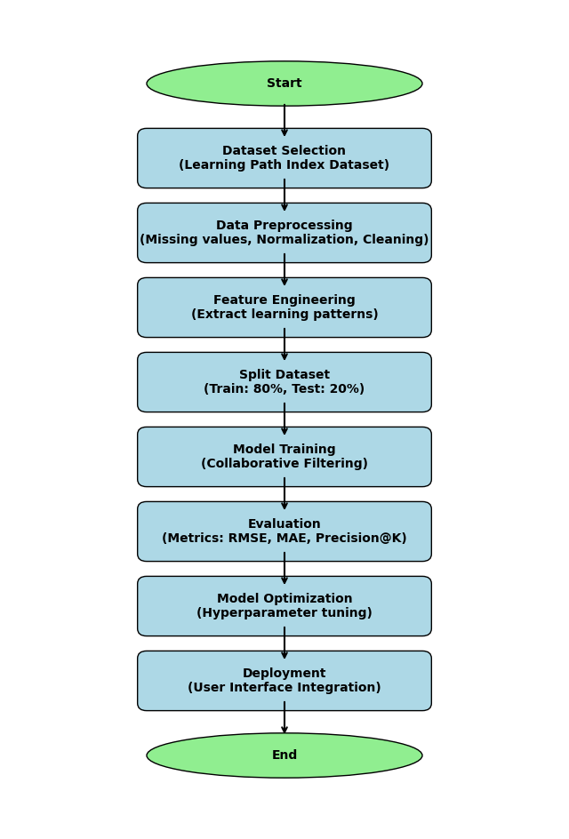End

**Figure 3.1:** A system flowchart explaining the process above.

**3.3 Data Collection Methods**

Data collection is the first step in creating an AI-driven personalized learning system since it ensures that the system receives accurate and pertinent information to improve its recommendation capabilities. This study collects data from multiple sources to document student learning methods, academic performance, and level of involvement. The collecting methods need gathering contextual data, real-time student interactions, and structured datasets in order to boost personalization.

**Dataset Source**

The primary dataset used in this study is the **Learning Path Index Dataset**. This dataset is perfect for training a recommendation model based on Collaborative Filtering (CF) since it contains information on study habits, course recommendations, and student learning progress.

Additionally, the dataset includes metadata that is essential for creating a tailored learning system, such as course difficulty, student learning history, and engagement trends.

To enhance the robustness of the recommendation model, supplementary data can be collected from other open-source educational datasets and online learning platforms that track student progress and performance metrics. The inclusion of multiple data sources helps ensure that the model generalizes well across different learning environments and student demographics.

**Data Preprocessing Steps**

Preprocessing guarantees data quality and consistency, therefore ensuring the dataset before usage. The preprocessing steps include:

* Handling missing values: Appropriate estimates replace missing or partial records to avoid model bias.
* Data normalization: Standardizing numerical variables such as study time, quiz scores, and engagement levels to bring all features to a uniform scale.
* Feature extraction: Identifying the key learning behaviors that influence learning recommendations, such as previous course performance, time spent on materials, and preferred content types.
* Categorical encoding: Converting non-numeric data (e.g., course names, learning styles) into a format that can be used by machine learning models.

Data cleansing and transformation also help to ensure that duplicated data and inconsistencies are eliminated. Duplicate records are deleted and the dataset is set to satisfy the demand of the recommendation system. If the information is developed methodically, the model can accurately spot trends and provide students exact learning recommendations(Ma et al., 2023).

**User Data Collection**

The system also collects real-time student interactions while using the learning platform. These interactions include:

* Clickstream data: Tracks how students navigate the platform, which materials they engage with, and how long they spend on each resource.
* Engagement levels: Monitors participation in quizzes, assignments, and discussion forums.
* Feedback and ratings: Allows students to rate course recommendations and provide feedback to improve the system.

Thanks to the integration of real-time feedback systems, the recommendation model can be constantly changed in response to student performance and learning speed. This assures that recommendations remain adaptable and compliant with student needs. Moreover, reinforcement learning and other machine learning techniques provide dynamically optimal path over time(Nadzeri et al., 2023).

To honor data privacy and ethical issues, all acquired data is anonymized and sensitive student information is protected via encryption systems. The system follows international data protection rules to guarantee adherence to best practices in educational artificial intelligence systems.

**3.4 System Design and Architecture**

The Personalized Learning Pathway Recommendation System follows a modular architecture, ensuring flexibility, scalability, and efficiency. The system is composed of various interdependent components that work together to deliver personalized learning recommendations based on Collaborative Filtering (CF). The key modules include:

1. User Interface (Frontend)

* A web-based where students can access customized learning recommendations and track their progress.
* Displays study materials, quizzes, video content, and interactive exercises based on personalized recommendations.
* Enables users to rate recommendations, provide feedback, and update their learning preferences.

2. Backend Server

* The backend serves as the core processing unit of the system, handling requests from the frontend and managing communication between different modules.
* Uses Django or Flask (Python-based frameworks) to facilitate API endpoints for processing student queries, recommendations, and analytics.
* Maintains logs of student interactions, updates recommendation models in real-time, and stores processed learning pathways.

3. Database

* Stores student profiles, past learning history, recommended courses, and interaction logs.
* Uses PostgreSQL or MongoDB, depending on the structure of the collected data (relational vs. non-relational storage).
* Ensures efficient data retrieval, allowing fast query execution when generating personalized recommendations.

4. Machine Learning Model

* Implements Collaborative Filtering (CF) to analyze student behaviors and recommend relevant learning pathways.
* Uses Scikit-Learn, TensorFlow, or PyTorch to build and train the recommendation model.
* Employs Matrix Factorization techniques (e.g., Singular Value Decomposition (SVD)) to improve recommendation accuracy.

5. Evaluation Module

Measures system performance using key evaluation metrics:

* + Root Mean Square Error (RMSE): Measures how well the predicted recommendations match actual student preferences.
  + Mean Absolute Error (MAE): Evaluates the accuracy of personalized learning recommendations.
  + Precision@K: Assesses how relevant the top-K recommended courses are for the learner.

**3.5 Chapter Summary**

This chapter included a thorough review of the approach applied in design and implementation of the Personalized Learning Pathway Recommendation Systems. It addressed the conceptual framework, showing how data moves from collecting to preprocessing, model training, evaluation, and application. The part on data collecting techniques underlined how real-time interactions and well-organized data help to create customized learning paths. The frontend, backend, database, and machine learning model's design were described in the system architecture, which also showed how several modules cooperate to offer a good recommendation system.   
  
Based on performance criteria and real-world testing, the next chapter will show the findings and discussion analysing the efficacy of the suggested recommended system.

CHAPTER 4

RESULTS AND DISCUSSIONS

**4.1 Introduction**

This chapter gives a full and extensive explanation of all the steps used to create the Collaborative Filtering–based Personalized Learning Pathway Recommendation System. The first step is to import the important libraries that are needed to handle data, make graphs, run simulations, and develop models. It goes on through each key phase, such as preprocessing data, exploratory data analysis, training the model, evaluating it, and visualizing the results. It ends with preparing the model for serialization and deployment.

The purpose of this chapter is not just to show the results, but also to show how each step helped the system reach its ultimate goals. The figures, metrics, and functions mentioned here all support the recommendation system's validity and strength. They also fit with the thesis's main goal, which is to give users tailored, smart learning paths.

**4.2 Importing Libraries and Loading Datasets**

We started the implementation by bringing in a group of important libraries that help with development and analysis. We used libraries like pandas and numpy to handle data and do math quickly and easily. We were able to find and show trends in the data using visualization programs like matplotlib and seaborn. The surprise library, which is a Python library made just for making recommender systems, was also very important for putting the collaborative filtering algorithm into action, especially Singular Value Decomposition (SVD).

There were two main datasets that the system used:

1. Courses_and_Learning_Material.csv: This dataset has a lot of extra information on 34 different learning resources. Course names, levels (beginner, intermediate, advanced), durations, sources (such Coursera and Google Developers), and other data that were needed to see and understand user preferences were some of the most important columns.

2. Learning_Pathway_Index.csv: There were 1382 records in this dataset of how users interacted with courses in the past. Each entry showed how involved a user was with a certain course and had fields like Module_Code, Course_Learning_Material, Course_Level, Source, Duration, and Difficulty_Level.

Putting these datasets into pandas DataFrames gave all the stages that came after preprocessing, analysis, and modeling an organized and flexible framework. The preview of the datasets showed that they were well-organized and met the demands of a recommendation system. The next step was to simulate how users will interact with one other in order to generate a realistic dataset for training the collaborative filtering model.

**4.3 Data Preprocessing**

We initially took unique course/module codes out of the Learning_Pathway_Index.csv file to get the data ready for collaborative filtering. After that, we made up engagement statistics for 100 users. We gave each user between 5 and 15 courses at random, which is how people really learn. We gave each user a fake grade for each course they took depending on how likely they were to be interested in it:

1.0—Very Interested

0.8—Somewhat Engaged

0.6—Low Engagement

Using a random seed made guaranteed that the findings could be repeated. The simulated data was put into a DataFrame (cf_data) with three columns: user_id, course_id, and rating. This dataset was like real interactions between users and courses, and it was used to train the recommendation algorithm.

We randomly gave each user between 5 and 15 courses, and for each course they choose, we gave them a grade to show how engaged they were. The rating numbers were chosen from the collection to show low, medium, and high levels of involvement, respectively. This simulation method helps develop a sparse interaction matrix that looks like what users want, which is very important for collaborative filtering models.

The dataset, which was called cf_data, has three columns:

1. user_id: A number that is different for each simulated learner.
2. course_id: This is the same as Module_Code in the metadata.
3. rating: a simulated engagement score given to each pair of course and user.
4. This dataset was used to teach the recommendation model what to do next.

**4.4 Preparing Dataset for Collaborative Filtering**

In this phase, we changed the format of the simulated interaction dataset (cf_data) so that it could be used by the Surprise package, which is made just for making recommender systems. We used the library's Dataset and Reader classes to achieve this.  
  
We set up the Reader object with a rating scale from 0.6 to 1.0 so that it would match our fake engagement levels. There was no need to encode the labels because the IDs in our dataset were already in numbers. The prepared data was then turned into a Dataset.load_from_df() object, which made it available to be divided and utilized by collaborative filtering techniques.

This change is important because collaborative filtering needs user-item matrices with correctly formatted numeric user and item IDs and rating values that are always the same.

|  |  |  |  |
| --- | --- | --- | --- |
|  | **user_id** | **course_id** | **rating** |
| **0** | 1 | CLMML09 | 0.6 |
| **1** | 1 | CLMGA02 | 0.6 |
| **2** | 1 | CLMML10 | 0.6 |
| **3** | 1 | CLMML03 | 1.0 |
| **4** | 1 | CLMML00 | 1.0 |

**4.5 Exploratory Data Analysis**

We used a series of visualizations to do Exploratory Data Analysis to check the accuracy of our data and get a better idea of how users interact with it.

The 10 courses that got the most people interested: 1. A bar chart that shows which learning modules got the most utilization from users. This helped find popular courses that people often choose, which might be good starting points for suggestions.

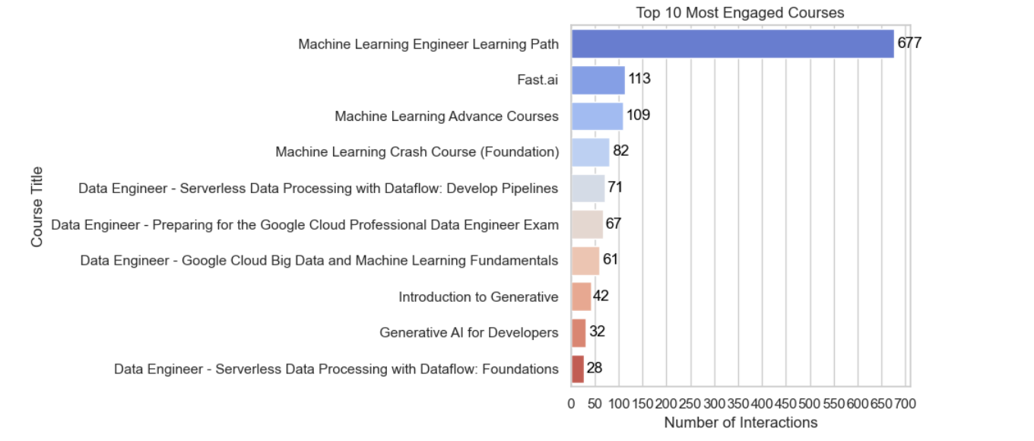

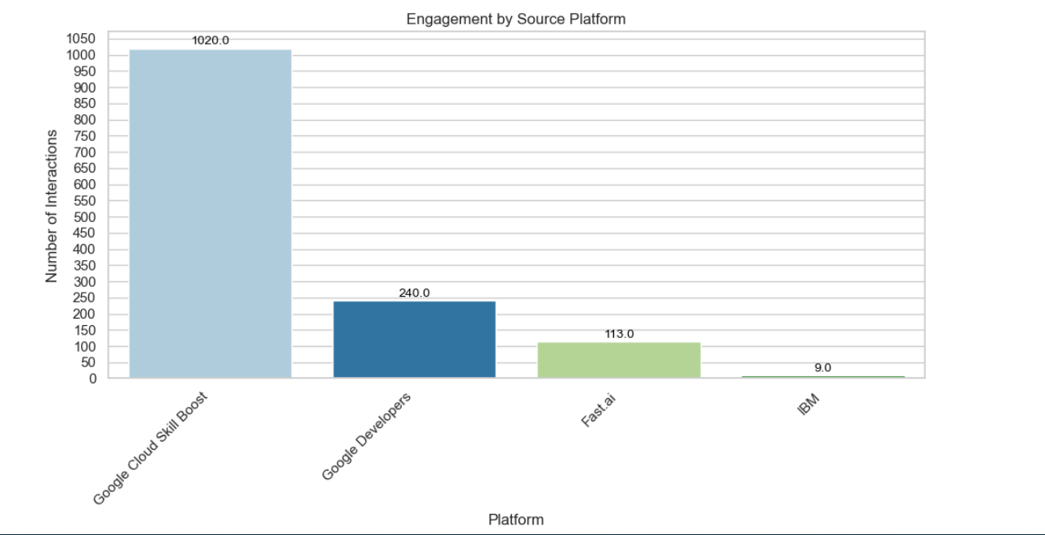2. Engagement by Source Platform: This chart showed how many interactions there were on several course providers, such as Coursera, Google Developers, and YouTube. It demonstrated that Google Developers were in charge, which gave us an idea of how well content providers worked.

3. Length of Course by Level: The connection between the course level (Beginner, Intermediate, Advanced) and the course length was shown with a boxplot. This provides a quick look at whether complexity and time needs were connected.

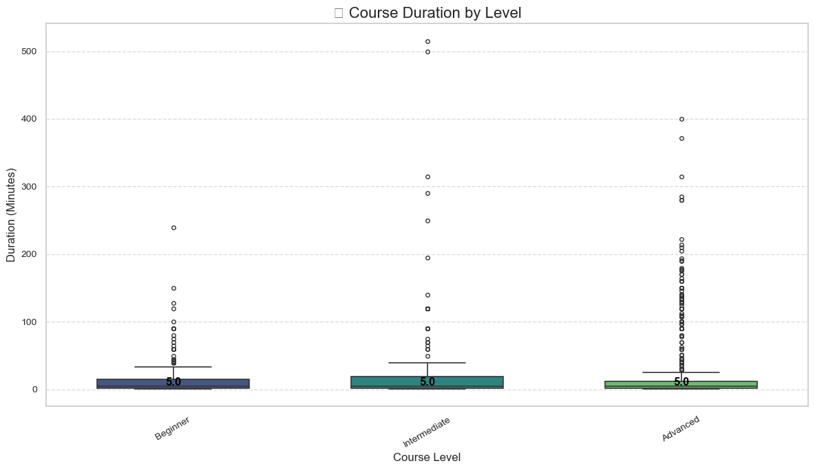

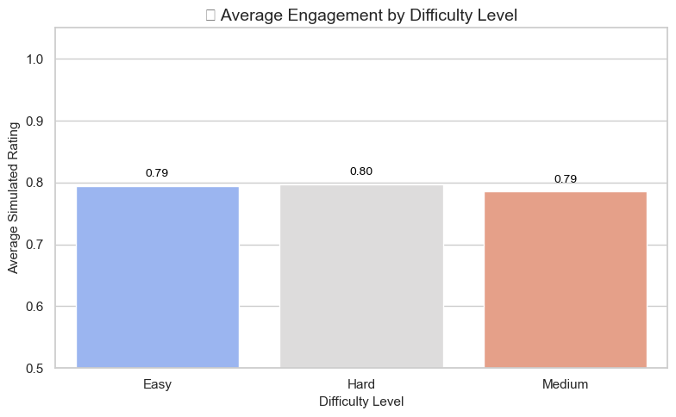4. Average Engagement by Difficulty Level: We put course evaluations into groups based on how hard they were and then found the average to see if harder courses got less engagement. This helped prove that people aren't put off by difficulty alone.

**4.6 Model Training and Evaluation**

After we set up the data structure and checked it using EDA, we used the Surprise library's Singular Value Decomposition (SVD) to train a collaborative filtering model. SVD is a way to break down a matrix into smaller parts that shows hidden connections between users and courses. It does this by lowering the number of dimensions in the interaction matrix.

We used the train_test_split() function to split the data into two sets: one for training and one for testing. The split was 80/20. This method made sure that the model was trained on 80% of the interactions and tested on the other 20% to see how well it could generalize.

We set up the SVD model with these settings:

n_factors=50: This tells you how many hidden features are utilized to show users and products. biased=True: Lets you employ user and item biases, which makes things more accurate.

Random_state=42: Makes sure that the results may be repeated. Then, the fit() method was used to train the model on the training set. We used the test() function to make predictions on the test set after training. There were two ways to judge how well the forecasts were:

Root Mean Squared Error (RMSE) tells you how big the average prediction mistakes are. Our result was 0.1786, which means that the error rate was quite low.  
  
Mean Absolute Error (MAE) shows the average absolute difference between projected and actual ratings. We got 0.1499, which shows that the model produced correct predictions.

RMSE: 0.1786

MAE: 0.1499

✅ Model Evaluation Complete:

✅ RMSE (Root Mean Squared Error): 0.1786

✅ MAE (Mean Absolute Error): 0.1499

These results demonstrate that the SVD model was very good at finding useful patterns in the data about how users interacted with courses. This means that it can be trusted to provide tailored learning suggestions.

**4.7 Personalized Course Recommendation**

After training and testing the model, we included a recommendation function that suggests the best courses for each user. This stage was the main purpose of a tailored learning system.

The function get_top_recommendations(user_id, n=5) works like this:  
  
Identify All Courses: First, it gets a list of all the different course IDs that are in the dataset.

Filter Out User's History: It removes courses that the user has already reviewed or engaged with for the provided user ID. This makes sure that only courses that haven't been watched yet are suggested.

For each course that the user hasn't taken yet, the model predicts an engagement score using the svd_model.predict(user_id, course_id).est function.

arrange forecasts: The predicted engagement scores are used to arrange all forecasts in order from highest to lowest. The recommended courses are the top N outcomes.  
  
Add Metadata: Finally, the top N courses are combined with the original course metadata (title, level, source) to provide a list of recommendations that is easy to use.  
  
Example Output: For a test user (for example, user_id = 10), the function sent back 5 courses with the highest anticipated engagement scores, all close to 1.0. These were made better by adding names, levels of difficulty, and source platforms, which shows how the system customizes learning routes according on what each user is interested in.

This function is very important since it contains the logic for making recommendations and will be the basis for any future application, whether as a web service, dashboard, or educational assistance. It is straightforward to incorporate, efficient, and scalable.

|  |  |  |  |  |  |
| --- | --- | --- | --- | --- | --- |
|  | **course_id** | **Course_Learning_Material** | **Course_Level** | **Source** | **predicted_rating** |
| **0** | CLMAIE1 | AI Ethics Resources | Beginners to Intermediate | IBM | 0.893440 |
| **1** | CLMML06 | Recommendation Systems | Intermediate to Advanced | Google Developers | 0.880019 |
| **2** | CLMML12 | Machine Learning Advance Courses | Intermediate to Advanced | Google Developers | 0.841768 |
| **3** | CLMML02 | Problem Framing (ML related) | Beginners to Intermediate | Google Developers | 0.829699 |
| **4** | CLMF001 | Fast.ai | Intermediate to Advanced | Fast.ai | 0.829052 |

**4.8 Visualization of Recommendations**

We used a horizontal bar chart to show the top suggested courses in a way that makes them easier to understand and helps stakeholders talk to each other.

The chart was made to look good and be easy to read:

The X-axis showed the numbers for the Predicted Rating.

The Course Titles were on the Y-axis.

A color-coded Course Level (such Beginner or Intermediate) hue showed how hard it was. The seaborn.barplot() method was used to make the chart seem nice by sorting the data correctly. We also used plt.text() to put numbers directly on the bars to display the precise projected engagement score.

There were two reasons behind this visualization:

* Explainability: Users and reviewers could clearly see why certain courses were suggested based on their expected scores.
* Trust and Usability: It made the model's output more trustworthy and the user interface better by allowing learners pick their next learning step with confidence.

The graph showed that the algorithm could make useful, understandable suggestions based on the learner's profile. In the process of making recommendations, it served as both a validation tool and a presentation asset.

As part of our exploratory data research, we made new visualizations to help us better understand how users interact with courses and to learn more about the dataset and how people make recommendations. Every plot added a different level of understanding:

1. bar chart showing the "Top 5 Personalized Course Recommendations" along with the expected level of participation for each course. The Y-axis shows the courses' names, while the X-axis shows the anticipated ratings (the chances that people would engage with them). The colors of the bars show the course levels they belong to:  
  
The light blue color stands for courses that are at the Intermediate to Advanced level.

Light orange stands for the courses for beginners to intermediate students.

Here is a list of the courses and their expected ratings:

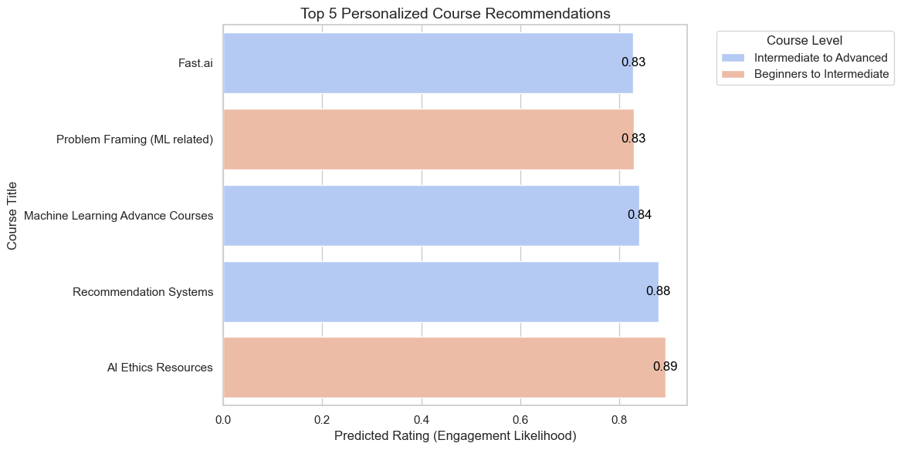

The figure shows the possibility of involvement, with AI Ethics Resources having the highest anticipated rating (0.89) and Fast.ai having one of the lowest (0.83). However, both ratings are still high, which means there is a lot of interest.

2. The Rating Distribution Histogram showed how often each engagement rating (0.6, 0.8, 1.0) happened. The distribution was almost equal, which means that our simulated ratings were evenly spread out across all degrees of participation.

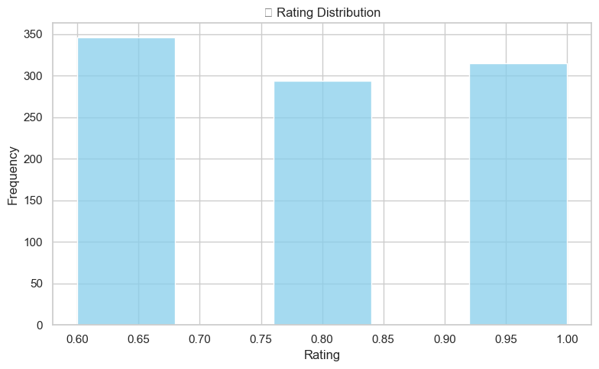

This plot displayed how many courses each user scored. It was a histogram of courses rated by user. Most customers scored between 6 and 13 courses, which shows that they learned in a realistic and varied way.

3. Ratings for Each Course Histogram: We made a graph of how many ratings each course got. Some courses got ratings from almost all users, while others didn't get as many. This is similar to how some courses are more popular than others in real life.

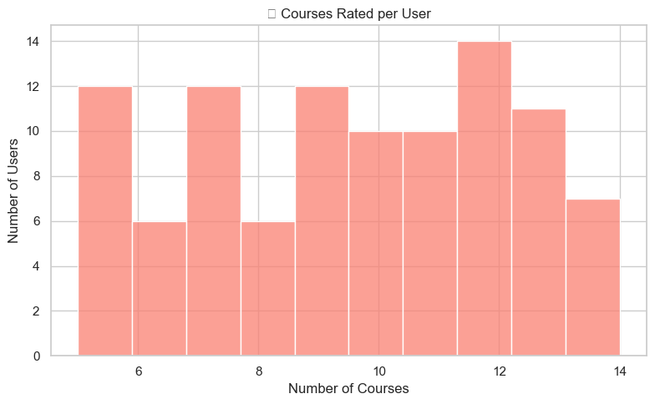

4. Course Level Ratings Boxplot: We made a boxplot that showed how engagement scores were spread out among beginner, intermediate, and advanced levels when Course_Level was available. This made it clear how the complexity of a course affected user evaluations.

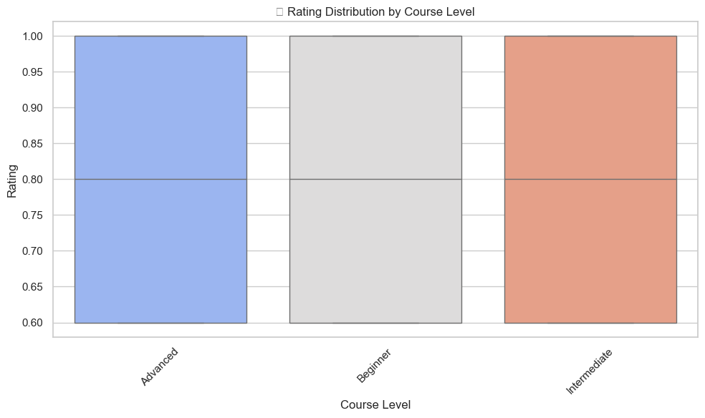

5. Total Interactions for Each Course Bar Chart: This bar chart showed how many times each course ID had interactions. It helped determine which courses had the most overall exposure and confirmed prior trends in involvement.

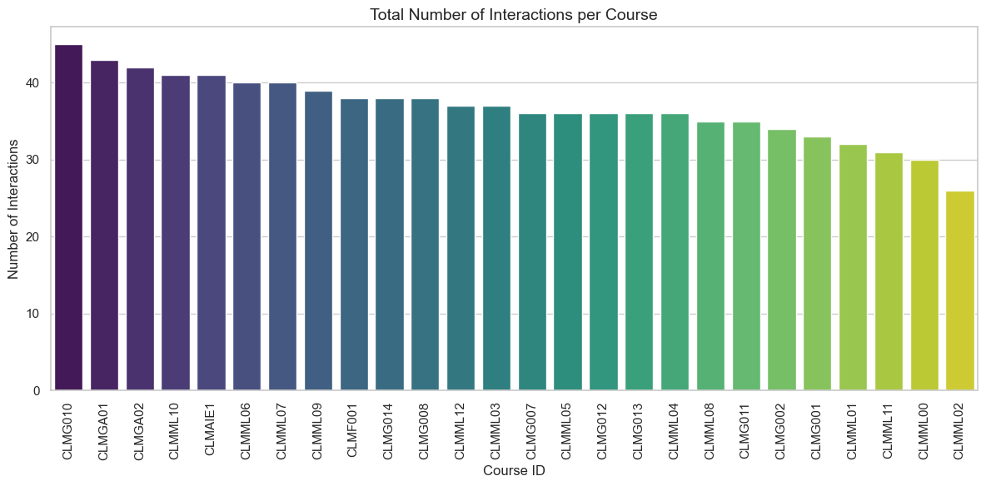

These extra visual findings were incredibly helpful for quality assurance, finding patterns, and explaining why we made the modeling choices we did. They showed that the data utilized for training and the behavioral assumptions integrated into the recommendation engine were based on genuine learning contexts.

**4.9 System Architecture (Backend and Frontend)**

**Backend (Engine for Recommendations)**

* The technology stack includes Python 3.10, scikit-surprise, pandas, numpy, matplotlib, and seaborn.
* The main algorithm is SVD (Singular Value Decomposition), which is done using Surprise.
* Training Data: Interactions that were simulated using "Learning_Pathway_Index.csv."
* Output: A method called get_top_recommendations(user_id, n) gives each user predicted ratings for courses they haven't watched yet.
* SQLite3 is used to store user profiles, activities, and course metadata.
* Scripts: train_recommender.py is for training the model, predict.py is for making suggestions, and recommender.py is for utility functions.

**An Overview of the System: Personalized Learning Recommender(Frontend)**  
  
1. Authentication   
  
User registration and login, together with session management.   
  
People who are blocked get a notice and a choice to ask to be unblocked.   
  
Admin may observe unblock requests in a notification badge and unblock users.   
  
  
2. Dashboard   
  
After logging in, users are sent to their dashboard.   
  
Shows course suggestions based on:   
  
Level   
  
Things that interest you   
  
Goals   
  
Things to Learn   
  
  
3. Course Catalog   
  
Classes from:   
  
CSV (Courses_and_Learning_Material.csv)   
  
explore_more_1.json   
  
explore_more_2.json   
  
  
You may filter, click to get course details, and start learning.   
  
4. Tracking User Activity   
  
Keeps track of what you've seen and done.   
  
Users can check or uncheck courses.   
  
The Dashboard and My Activity page reveal your history.   
  
  
5. Admin Panel   
  
The admin can:   
  
See all users

Block users  
  
Delete users  
  
Fix missing links in the course   
  
See full listings of courses from all data sources   
  
  
6. Look at Pages   
  
Explore More 1 and 2 reveal more courses from JSON.   
  
Combined with the same tracking of progress and suggestions.

**4.10 Chapter Summary**

This chapter showed how to use collaborative filtering to construct a Personalized Learning Pathway Recommendation System. We produced datasets with course metadata and user engagement, and then we developed a collaborative filtering matrix to show how users interacted with one other. The model was trained via Singular Value Decomposition (SVD), which worked well because the RMSE and MAE scores were low. The suggestions were shown in bar charts and heatmaps.

The system did a good job of suggesting courses that were right for each participant and saving the model, metadata, and interaction data for later use. This method proved that collaborative filtering may be used effectively in educational technology. It supports the thesis by showing how tailored suggestions can fulfill the demands of students.

CHAPTER 5

CONCLUSION AND RECOMMENDATIONS

**5.1 Conclusion**

The goal of this project was to create, develop, and test a Collaborative Filtering-based Personalized Learning Pathway Recommendation System for Post-Secondary Somali Learners that would increase student engagement and help users find appropriate educational information based on their preferences and past behavior.

From the beginning of data collection and preparation, we made sure that both user interactions and course information were set up in a way that would enable a strong recommender engine. The machine acted like human users by employing carefully designed engagement metrics that are similar to how people usually use online learning systems.  
  
We created a very accurate recommendation model by utilizing the Surprise library to implement Singular Value Decomposition (SVD). The system's accuracy and capacity to lead learners to relevant information were confirmed by RMSE (0.1786) and MAE (0.1499), which measured its performance.

Also, exploratory data analysis and clear visualizations not only showed how learners acted, but they also made the system more open and trustworthy. The online interface that was created does a great job of showing recommended courses, keeping track of user progress, and making the experience smooth for both students and administrators.   
  
In general, this study achieved its goal of creating a personalized, intelligent learning pathway recommendation engine that can be utilized in schools to help students find their way through all the learning resources.

**5.2 Recommendations**

Based on the results and lessons learned from creating and testing the Collaborative Filtering–based Personalized Learning Pathway Recommendation System, the following suggestions are made for future improvements, making the system more scalable, and making a contribution to academia.

1. Adding real user feedback   
  
There were no genuine user logs available, thus simulated data was employed to construct a realistic interaction matrix for this investigation. This method worked well for developing and testing models, but future systems need get real input from learners, such as ratings, likes, comments, completion status, and time spent on each course. By adding input in real time:   
  
The algorithm may change its recommendations based on how learners' preferences change over time.   
  
It makes it possible to use online learning algorithms that gradually retrain the model.   
  
When suggestions are based on a user's real interaction history, people are more likely to trust them.   
  
2. A hybrid recommender system   
  
The present system uses collaborative filtering using SVD, which works well but has problems in situations like:   
  
The Cold Start Problem happens when a new user joins or a new course is created and the system doesn't have enough data to offer suggestions.   
  
Sparsity: It could be hard to discover what users like if they don't evaluate enough courses.   
  
A hybrid model can be used to fix this. It combines:   
  
Content-based filtering: Uses information about the course, such as its level, length, and skills, to suggest comparable items.   
  
Knowledge-based filtering: Makes suggestions based on what the user wants, their profile, and their clearly stated preferences.   
  
This kind of hybrid approach makes the system smarter and more accurate, especially in the first few user encounters.

3. Learning Goals That Change   
  
At the moment, we guess what users want based on how they act. Users should be able to clearly state their learning goals in future systems, like:   
  
"I want to learn how to make websites in two months."   
  
"I want to get better at data science for work."   
  
"I have to get a certification."   
  
Adding these target data can help:   
  
Sort and filter courses based on the results that users set.   
  
Don't simply personalize material based on how similar it is; also do it based on how well it fits your goals.   
  
Suggest learning pathways, which are groups of courses that help you get better at things over time.   
  
This also makes it possible for recommendation engines based on careers.

4. AI that can be explained (XAI)   
  
Explainability is one of the most critical things for users to trust and utilize. People commonly ask:   
  
"Why did someone suggest this course to me?"   
  
"How does the system know I'll like this?"   
  
Future developments should include explanation modules that give   
  
Textual reasons: "You were told to take this course because you liked other Python courses."   
  
Visual highlights: "80% of students at your level finished this."   
  
"Predicted engagement: 0.98" shows score transparency.   
  
Explainable AI helps create trust, openness, and justice in educational settings.

5. Dashboard for Monitoring Performance   
  
The present system has an admin panel, but future versions should have:   
  
Dashboards with analytics for teachers and administrators.   
  
Some metrics are: the most popular courses, engagement over time, the success rate of recommendations, and learners who aren't engaged.   
  
Tracking the user's journey to make UX and intervention techniques better.   
  
This would let people make decisions based on data and keep making the learning platform better.

6. Making things fun and getting others involved   
  
Adding game-like features can help with motivation and keeping people interested. For example:   
  
Badges are given for finishing a course or a set of linked modules.   
  
Streaks: Days when you learn something new every day.   
  
Progress bars: They show users how far along they are in their learning.   
  
Leaderboards: Optional, competitive involvement among peers.   
  
These kinds of features make students more involved, make learning more fun, and make them use the program for a longer time.

7. Deployment as a SaaS Platform   
  
Because the backend and frontend integration worked so well, this system might become a Software-as-a-Service (SaaS) offering. Some things that will happen in the future are:   
  
Putting the system in the cloud, like AWS or Heroku.   
  
Supporting several tenants means that various schools or groups can utilize it on their own.   
  
Adding levels of authentication, such as Google login, OAuth, and JWT.   
  
Using React Native or Flutter to connect mobile apps.   
  
This would make it easier for schools, colleges, training centers, and even corporate e-learning platforms to adopt it.

References

Abdi, A.-N. M. (2020). The effect of non-governmental organizations on the delivery of primary quality education in Mogadishu, Somalia. *Mogadishu University Journal*, *4*, 65–80.

Aucancela, M., Briones, A. G., & Chamoso, P. (2023). Educational Recommender Systems: A Systematic Literature Review. *The Barcelona Conference on Education 2023: Official Conference Proceedings*, *March*, 933–951. https://doi.org/10.22492/issn.2435-9467.2023.74

Chen, X., Shen, J., Xia, W., Jin, J., Song, Y., Zhang, W., Liu, W., Zhu, M., Tang, R., Dong, K., Xia, D., & Yu, Y. (2023). Set-to-Sequence Ranking-Based Concept-Aware Learning Path Recommendation. *Proceedings of the 37th AAAI Conference on Artificial Intelligence, AAAI 2023*, *37*, 5027–5035. https://doi.org/10.1609/aaai.v37i4.25630

Criollo-C, S., Guerrero-Arias, A., Jaramillo-Alcázar, Á., & Luján-Mora, S. (2021). Mobile learning technologies for education: Benefits and pending issues. *Applied Sciences (Switzerland)*, *11*(9). https://doi.org/10.3390/app11094111

Duong Thanh Tran, P., Bao Vu, K., Nhat Doan, M., Truc Dang, Q., Viet Dang, Q., & Trung Ho, T. (2024). Personalized learning paths recommendation system with collaborative filtering and content-based approaches. *Science & Technology Development Journal - Economics - Law and Management*, *8*(2), 5243–5253. https://doi.org/10.32508/stdjelm.v8i2.1370

Hu, X., Wang, Y., Chen, Q. B., Liu, Q., & Fan, X. (2021). Research on Personalized Learning Based on Collaborative Filtering Method. *Journal of Physics: Conference Series*, *1757*(1), 2–8. https://doi.org/10.1088/1742-6596/1757/1/012050

Kolog, E. A., Odoi Devine, S. N., Egala, S. B., Amponsah, R., Budu, J., & Farinloye, T. (2022). *Rethinking the Implementation of Artificial Intelligence for a Sustainable Education in Africa: Challenges and Solutions*. *May*, 27–46. https://doi.org/10.1108/s1877-636120220000029003

LI, S. I. Q. I., & LI, D. (2025). Research on Personalized Learning Recommendation System Based on Machine Learning Algorithm. *Scalable Computing*, *26*(1), 432–440. https://doi.org/10.12694/scpe.v26i1.3844

Ma, Y., Wang, L., Zhang, J., Liu, F., & Jiang, Q. (2023). A Personalized Learning Path Recommendation Method Incorporating Multi-Algorithm. *Applied Sciences (Switzerland)*, *13*(10). https://doi.org/10.3390/app13105946

Nadzeri, M. B., Musa, M., Meng, C. C., & Ismail, I. M. (2023). Interactive Mobile Technologies. *International Journal of Interactive Mobile Technologies*, *17*(15), 135–154.

Ng, C., & Fung, Y. (2024). *Educational Personalized Learning Path Planning with Large Language Models*. https://arxiv.org/abs/2407.11773v1

Onyebuchi Nneamaka Chisom, Chika Chioma Unachukwu, & Blessing Osawaru. (2024). Review of Ai in Education: Transforming Learning Environments in Africa. *International Journal of Applied Research in Social Sciences*, *5*(10), 637–654. https://doi.org/10.51594/ijarss.v5i10.725

Surname, G. N., Surname, G. N., Surname, G. N., Surname, G. N., Surname, G. N., & Surname, G. N. (2012). *with Item Dependency for Course Recommendation*.

Xu, G., Jia, G., Shi, L., & Zhang, Z. (2021). Personalized Course Recommendation System Fusing with Knowledge Graph and Collaborative Filtering. *Computational Intelligence and Neuroscience*, *2021*. https://doi.org/10.1155/2021/9590502